OF MICE AND MEN

- GCSE English Language – controlled assessment. Unit four, Task 2 – The Study of Written Language
- GCSE English Literature – Unit one exam – prose.

Controlled Assessment Title:

The theme for your writing is
RELATIONSHIPS
Analyse the presentation of relationships in Of Mice and Men by John Steinbeck.

TITLE: Discuss the relationship between
George and Lennie.
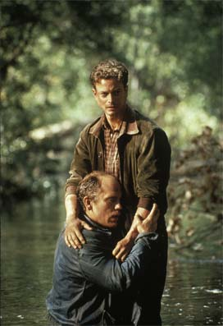

This task is worth 15% of your final GCSE grade. It allows you to demonstrate your knowledge of characters, themes or genre in an extended literary text. Your text is Of Mice and Men by John Steinbeck.

Your controlled assessment will last for 1 ½ hours.
GCSE English.

- There are 2 external examinations
and
- Coursework has been replaced with 3 written controlled assessments and a controlled assessment in Speaking and Listening.

This booklet contains tasks which will prepare you for your controlled assessment in
Unit 4: Studying Spoken and Written Language and Writing Creatively (Task 2 – The Study of Written Language).

Controlled assessments will take place under examination conditions.

This task is worth 15%. It allows you to demonstrate your knowledge of characters, themes or genre in an extended literary text. Your text will be Of Mice and Men by John Steinbeck.

Content | Learning Outcomes
The Study of a Literary Text | Students should be able to:
 | Read and understand texts.
 | Understand how meaning is constructed.
 | Recognise the effect of language choices and patterns.
 | Select material appropriate to purpose.
 | Evaluate how texts may be interpreted differently depending on the perspective of the reader.
 | Explain how writers use linguistic and presentational features to sustain the reader’s interest.

GCSE English Literature
You will also have an exam on ‘Of Mice and Men’ in summer 2013.
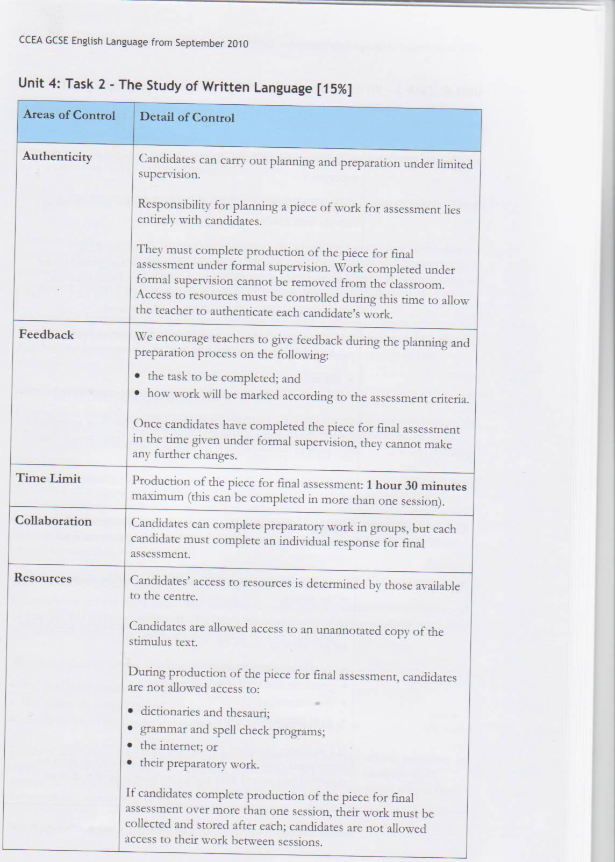

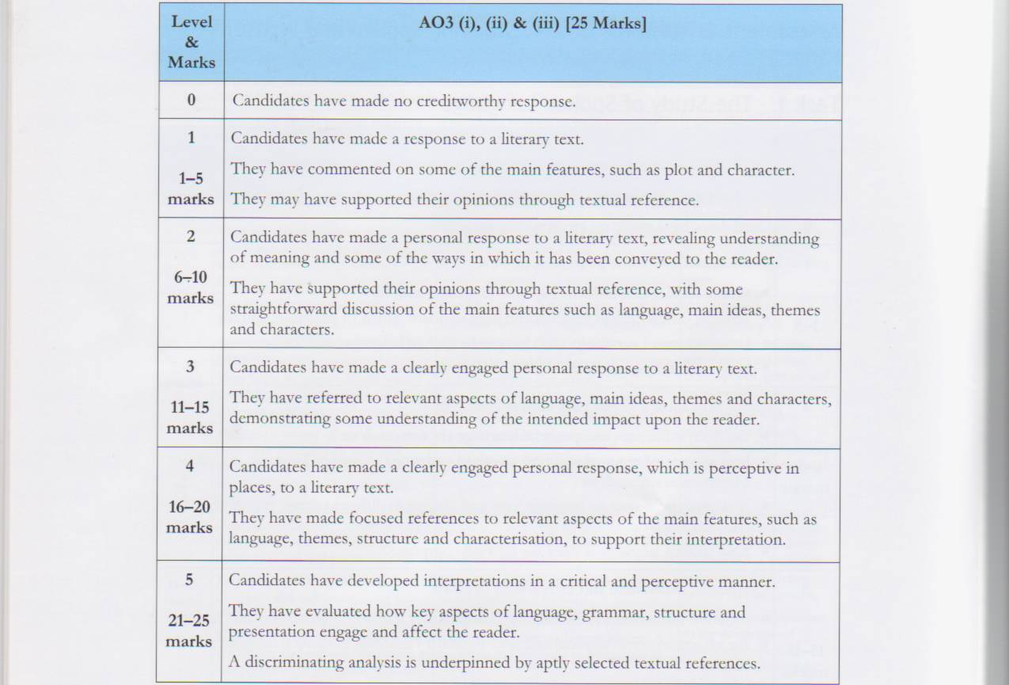
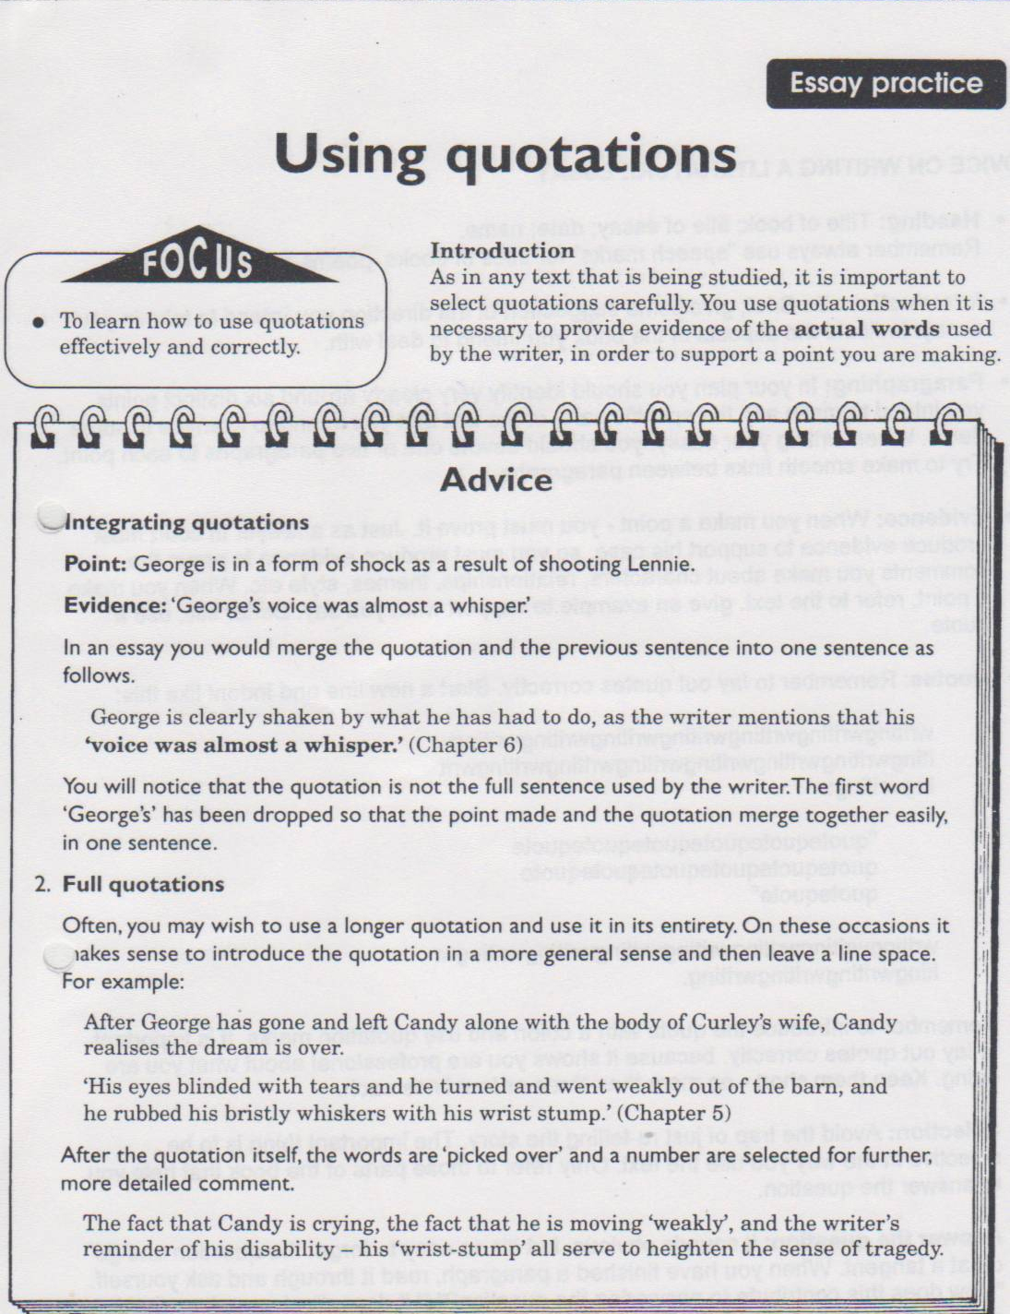
Homework

Social and Historical Context

Whenever you read a novel, it is important that you understand its historical and social context. In other words, you should know what was happening at the time it was written and / or set.

Of Mice and Men is set in America in the 1930s. This was a time of great upheaval, due to the catastrophic event which occurred in 1929. Use the internet or your novel to gather information on the context of the novel. Answer the 10 questions.

  - Who wrote Of Mice and Men?
____________________________________________________________
  - When was the novel written?
____________________________________________________________
  - When was the novel set?
____________________________________________________________
  - Where is the novel set?
____________________________________________________________
  - What does Soledad mean?
____________________________________________________________
  - What happened in America in 1929?
____________________________________________________________
  - What did this lead to in the 1930s?
____________________________________________________________
  - What was the American Dream?
____________________________________________________________
  - What was a migrant or itinerant farm worker?
___________________________________________________________
  - How were blacks segregated from whites in America in the 1930s.
____________________________________________________________
Use your answers to write a paragraph about the social and historical context of the novel.
_________________________________________________________________________________________________________________________________________________________________________________________________________________________________________________________________________________________________________________________________________________________________________________________________________________________________________________________________________________________________________________________________________________________________________________________________________________________________________________________________________________________________________________________________________________________________________________________________________________________________________________________________________________________________________________________________
Inferential questions – reading between the lines
Section two

- George plays solitaire in this section. What do you think is the significance of this game? What does it symbolise?
- How does this link to the name of the town near the ranch (Soledad)?
- Based upon what you already know about her, why do you think Curley’s wife flirts with the ranch hands even though she is a newly-wed?
- Why do you think George warns Lennie to stay away from her? What do you think might happen?

Describing a Character using adjectives

Draw a picture of Curley in the middle of your page based on the description of him on page 46.

Around the picture write down five adjectives to describe Curley based on what you have read in Section 2. (one word could be PUGNACIOUS).

Underneath each adjective – find a quote from the novel to support this e.g.

PUGNACIOUS
When Curley met George and Lennie ‘his hands closed into fists’.

Extra Questions
- Why is he is so angry?
- Why does he seem to dislike Lennie?
- Why is he a source of conflict on the ranch?
- What do you learn about his wife from Candy?

A Conflict of Conscience

We may have done things which were unpleasant, distasteful or even dangerous, but which, at the time, we felt we had to do.

We may say “I had no choice”; a phrase often used by people to excuse or defend an unpleasant action. Sometimes it is true, sometimes it is not. Sometimes it is a genuine conflict of conscience; sometimes a poor attempt to excuse personal weakness. Only the individual really knows.

“I had no other choice but to …”

In the book, Of Mice and Men, Carlson convinces old Candy that they have no other choice but to shoot the dog.


Find three reasons why Carlson says they should shoot the dog.
1
2
3

List three reasons why the dog means so much to Candy.
1
2
3

Based upon the information above, what conflict do you think Candy is experiencing?
______________________________________________________________________________________________________________________________________________________________________________________________________________________________________________________________________________________________________________________________________________________________________________________________________________________________________________________________________________________________________________________________________________________________________________

Themes
Loneliness

- A major theme in the novel.

- George to Lennie ‘Guys like us are the loneliest guys in the world’ (itinerant ranch hands without permanent ties).

- George plays the card game – solitaire – a game to be played by oneself.

- Soledad – setting – meaning ‘loneliness’

- Crooks – lonely because of segregation – says a ‘guy goes nuts’ if he doesn’t have anyone to talk to.

- Candy – loses his only companion or only true friend – his dog. Realises that due to his age he will soon have no place on the ranch or in society.

- Curley’s wife – she is the only woman in a male dominated environment, she is not valued, she feels rejected by both her mother and her husband. She is treated as a possession and has no one to confide in.

- The loneliest characters – Crooks, Candy and Curley’s wife are also the misfits or outsiders.

Homework – State who you feel is the loneliest character in the novel. Use evidence from the novel to support your answer (inc. quotations). No more than one side A4.

Essay Practice

Sources of Conflict in the novel

Conflict is a major theme in the novel as it represents the real world. Their dream is only a fantasy and the conflict throughout shows that the real world is violent, cruel and unforgiving.

There are many examples of conflict throughout the novel, caused by a range of factors:
- Black versus white
- Men versus women
- Strong versus weak
- The all male environment
- Loneliness / boredom / unhappiness leading to aggression.
- Lennie’s inability to fit into society

Task:
Discuss the role of conflict in ‘Of Mice and Men’.

- ◻The historical and social context of the novel. The Wall Street Crash, the Depression, itinerant lifestyle, lack of family ties / close relationships all lead to conflict, arising from anger and loneliness at their situation.

- ◻All male environment on the ranch (apart from Curley’s wife) leads to conflict – release of male aggression.

- ◻George’s internal conflict concerning Lennie – he knows that Lennie holds him back, but he hangs on to him as he is the only constant in his life and he provides George with a reason for dreaming.

- ◻George and Candy both go through the same internal conflict; whether or not to put the one they care about out of misery. They both choose yes, although Candy did not choose to do it himself.

- ◻Curley causes conflict – he seeks it out and causes many disputes between the men because of his own insecurities. His jealousy concerning his wife and the other ranch hands.

- ◻The conflict which Crooks experiences as a result of racism and segregation.

- ◻Curley’s wife causes conflict and disruption on the ranch. George knows that she is trouble.

- ◻Conflict between Lennie and society. Lennie is not accepted by the farmhands and is belittled by many. He can never be fully accepted into society because of his uncontrollable impulses which have lead to the death of others and ultimately his own as well.

- You should discuss at least five of these points in your essay.
- Tick which ones you want to write about.
- You will develop these points with more detail in your own words (and supporting quotations).

Your final essay should have at least seven paragraphs
(1=introduction, 2-6=main points and 7= conclusion)
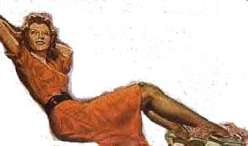
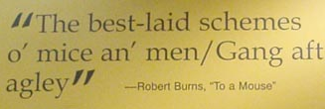
Self-assessment

Curley’s wife
The title/the poem
Symbols are objects which are used to represent other things or ideas. If an object or character is mentioned often, it is probably important. Another way to find a symbol is to look at how much detail is used in describing an object. Symbols often represent an important issue of the time in which the author lived, or has personal significance for the writer.
Did I … | Yes or No? | If ‘No’, please make your correction and then tick this column.
- refer back to the essay title.
- state again that conflict appears throughout the novel.
- state again why conflict is a major theme in the novel.
- summarise my main points.
- use a connecting word / phrase at the beginning of the paragraph?
Connecting words / phrases

Use these at the beginning of each paragraph

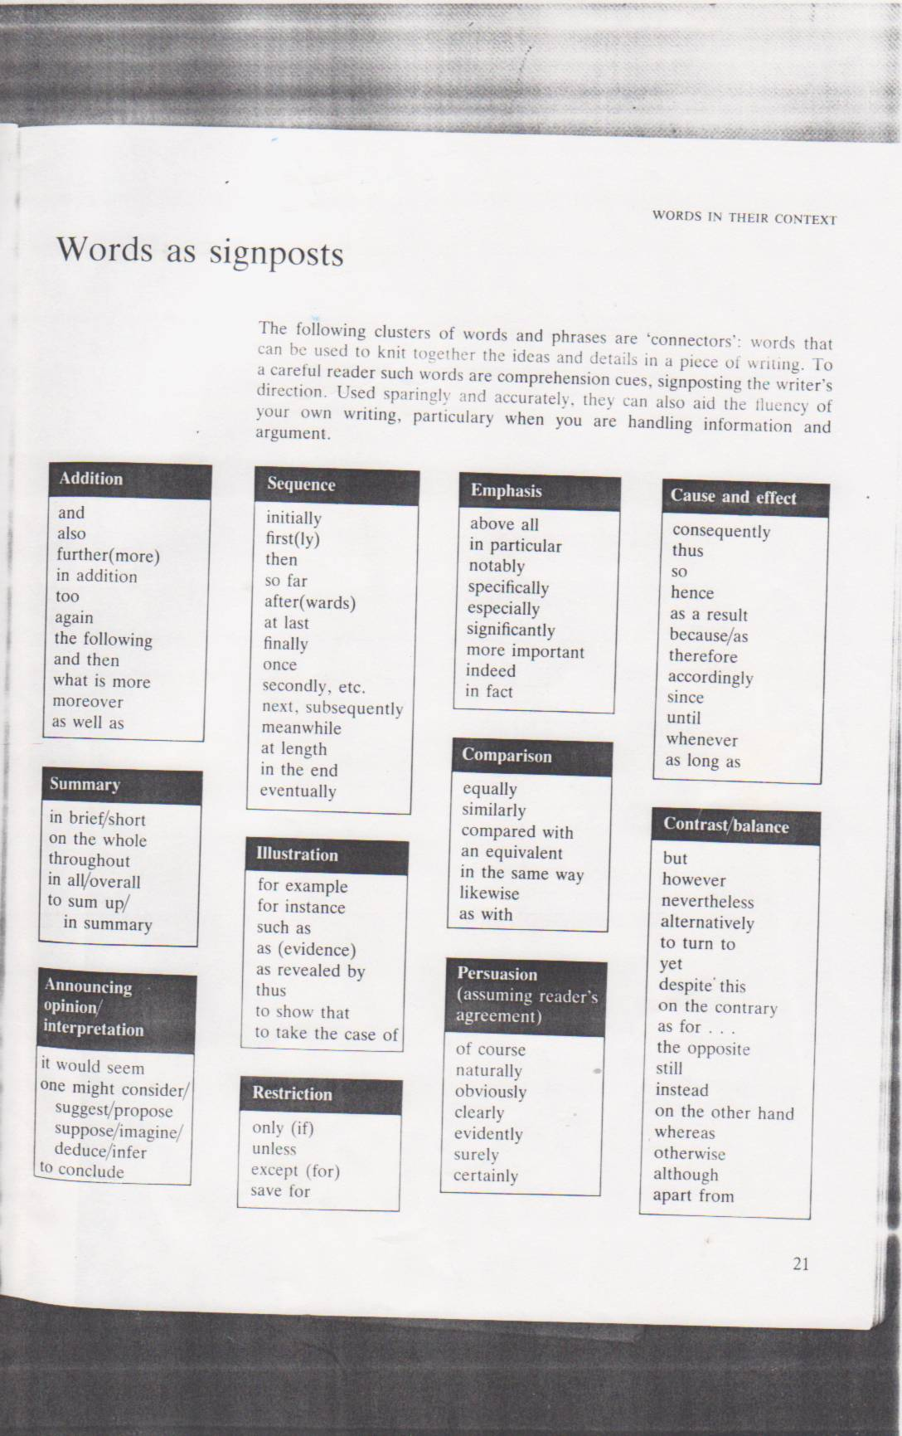

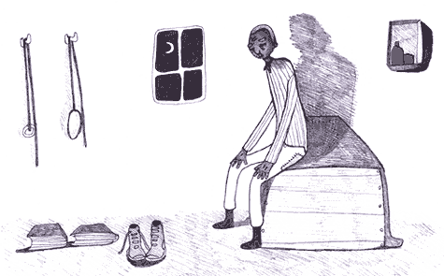

Watch the DVD of Of Mice and Men (when the viewer sees Crooks in the stable). Take notes on the following areas:
Appearance
_________________________________________________________________________________________________________________________________________________________________________________________________________________________________________________________________________________________________________________________________________________________
Description of his room
_________________________________________________________________________________________________________________________________________________________________________________________________________________________________________________________________________________________________________________________________________________________

Reaction to visitors i.e. words
____________________________________________________________________________________________________________________________________________________________________________________________________________________________________________________________________________________
_______________________________________________________________________________________________________________________________________________________________________________________________________________
Reaction to visitors i.e. facial expressions
_______________________________________________________________________________________________________________________________________________________________________________________________________________
_______________________________________________________________________________________________________________________________________________________________________________________________________________
HISTORICAL CONTEXT – You need to know what was happening in the world at the time when the novel was written / set.

Segregation in 1930’s America
Following the stock market crash of 1929 African Americans in both cities and rural areas, many already living in poverty, suffered greatly from the economic depression. When Franklin Delano Roosevelt was elected in 1932, he promised a "new deal" for all Americans that would provide them with security from "the cradle to the grave." However, the New Deal programmes did not end the Depression.
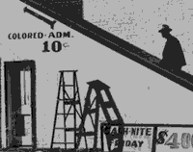 A Black Man Entering Movie Theatre by "Colored" Entrance. October 1939.
The North was less segregated than the South. In the North blacks were allowed to vote, except there were very few blacks who lived there. Black people were still denied entrance to the best hotels and restaurants.

In the 1930's, during the Great Depression, black protests increased against discrimination. They protested against the refusal of white-owned businesses in all-black neighbourhoods to hire black salespersons. Their slogan was "Don't Buy Where You Can't Work."
In 1938, the courts displayed a new attitude towards black rights. That year the Supreme Court ruled that Missouri was obligated to provide access to public law school for blacks, just has it provided one for white people. At this stage, education remained segregated.
Back then, black people also had to sit at the back of the bus and the whites sat up front. White drivers were often rude and abusive. In November 1956, a federal court ordered the buses to be desegregated.

Character Description - CROOKS
Crooks is so named because of a crooked back caused by a kick from a horse. Crooks is the stable hand who takes care of the horses and lives by himself because he is the only black man on the ranch. Along with Candy, Crooks is a character used by Steinbeck to show the effects of discrimination. This time the discrimination is based on race, and Crooks is not allowed in the bunkhouse with the white ranch hands. He has his own place in the barn with the ranch animals. Candy realises he has never been in Crooks’ room, and George’s reaction to Crooks being involved in their dream is enough to cause Crooks to withdraw his request to be part of the dream. Racial discrimination is part of the microcosm Steinbeck describes in his story. It reaches its height in the novel when Curley’s wife puts Crooks “in his place” by telling him that a word from her will have him lynched. Interestingly, only Lennie, the flawed human, does not see the colour of Crooks’ skin.

Crooks also has pride. He is not the descendent of slaves, he tells Lennie, but of landowners. In several places in the story, Steinbeck shows Crook’s dignity and pride when he draws himself up and will not “accept charity” from anyone. Crooks also displays this “terrible dignity” when Curley’s wife begins to tear away at his hope for the dream farm.

Crooks is not without his faults, however. He scares Lennie and makes up the story of George leaving him. Prejudice isn’t simply a characteristic of the white ranch hands or the daughter-in-law of the boss; it is a human characteristic, and Crooks needs to feel superior to someone also.

That he becomes part of the dream farm is an indication of Crooks’ loneliness and insecurity. He, like Candy, realizes that once he is no longer useful he will be “thrown out.” Where, then, can he find some security for his future? The dream farm of Lennie’s seems to be the place. Crooks promises to work for nothing as long as he can live his life out there without the fear of being put out. Like all the others, he wants a place where he can be independent and have some security. But there is no security for anyone in a prejudiced world, least of all a black stable hand with a crooked back.
This question is about Crooks.

Discuss how Steinbeck makes us feel sympathy for Crooks.

In your answer you should consider:
- Segregation of black and white
- The hostility that Crooks shows to Lennie and Candy
- The men’s physical abuse of Crooks
Planning – find the quotes which you will use in your essay.

A few have already been done for you.

An outsider – race and disability
__________________________________________________________________________________________________________________________
Ranch is segregated – microcosm of society at that time
__________________________________________________________________________________________________________________________
Hostility, his ‘scowl’, arises from self-protection
__________________________________________________________________________________________________________________________
He has learnt to be cynical –
‘Nobody can’t tell what a guy’ll do’

Tries to hurt Lennie about George, as he has been hurt by others rejecting him.
_____________________________________________________________
Reveals that he also suffers from loneliness
‘Books ain’t no good. A guy needs somebody.’

We are reminded of how important it is that George and Lennie have each other, as loneliness can destroy a man.
__________________________________________________________________________________________________________________________

Crooks momentarily allows himself to be pulled in by the dream. He was brought up on a chicken ranch with his family. Now he has no one. Curley’s wife reminds him of his place in society.
_____________________________________________________________

As a black man he had few rights. He could be ‘lynched’ without trail if she accused him of rape.
_____________________________________________________________

Through Crooks we are forewarned that a dream can be destroyed by others – ‘Nobody gets to heaven, and nobody gets no land.’

Self-Evaluation
Essay about Crooks

How did I do?
Did I? | Yes or No? | If your answer was ‘No’, tick this column when you have completed your corrections.
Use a range of quotations (at least five)
Put inverted commas at the end and beginning of each quotation.
Describe the historical context in relation to Crooks, racism and segregation.
Take a new paragraph for each new point.
Write a suitable introduction, referring to the essay question.
Write a concluding paragraph, referring to the essay question.
Complete my spelling corrections (four times each)
Use connecting words at the beginning of each new paragraph.
Once this has been completed, you can submit your essay for marking.
Setting
What do the following places represent?

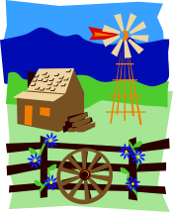
For example,
The ranch = The ranch is a microcosm of American society at that time. The loneliness, conflict and prejudice which occurs there, were all happening in society outside the ranch. During the 1930’s women and black people were not treated as equals and the treatment of Curley’s wife and Crooks demonstrates this.

Soledad =

The pool=

Beginning and Ending

Re-read the beginning and ending of the novel.

‘Of Mice and Men’ is a framed novel, as it begins and ends by the pool in the river. This creates a frame for the action and provides a sense of symmetry. Much of the language is repeated and it feels like the novel has come full circle. This structure creates a sense of inevitability and makes the tragic ending of the novel easier to bear.

How is this done?
- These two creatures are introduced in chapter one? ___________ and ____________
- In chapter six, the ___________ eats the ____________.
- What does this show? ______________________________________________________________________________________________________
- This is the last death before Lennie’s. There are a number of deaths throughout the novel, which build up to (or foreshadow) Lennie’s death. Identify all the deaths that occur throughout the novel. Put them in chronological order and include animal as well as human deaths.

Learning Intention: To understand how a writer’s choice of words can create a specific effect.

Question:
How has the writer created a peaceful atmosphere?
In your answer consider:
- The effectiveness of the writer’s description of the setting.
- The use of words and phrases.

Before you begin to type your answer, highlight the ‘Word Classes’ and ‘Stylistic Effects’ which you are going to use as evidence.
____________________________________________________________
The deep green pool of the Salinas River was still in the late afternoon. Already the sun had left the valley to go climbing up the slopes of the Gabilan mountains, and the hilltops were rosy in the sun. But by the pool among the mottled sycamores, a pleasant shade had fallen.

A watersnake glided smoothly up the pool, twisting its periscope head from side to side; and it swam the length of the pool and came to the legs of a motionless heron that stood in the shallows. A silent head and beak lanced down and plucked it out by the head, and the beak swallowed the little snake while its tail waved frantically.

A far rush of wind sounded and a gust drove through the tops of the trees like a wave. The sycamore leaves turned up their silver sides, the brown, dry leaves on the ground scudded a few feet. And row on row of tiny wind waves flowed up the pool’s green surface.

As quickly as it had come, the wind died, and the clearing was quiet again. The heron stood in the shallows, motionless and waiting. Another little watersnake swam up the pool, turning its periscope head from side to side.

Answer: This has been started for you …
The Salinas river is described as being ‘deep’ and ‘still’. These adjectives convey a sense of tranquillity; as there is no movement on the water, not even a slight ripple. This adds to the peaceful atmosphere, as the reader imagines this place as being quiet and soothing, without the intrusion of noise and action.

- What was the American Dream about?
- Why did it fall apart during the Great Depression?
- What is George and Lennie’s specific American Dream?
- Which other characters have dreams?
- What are they?
- Do any characters achieve their dreams?

Lennie is compared to various animals.

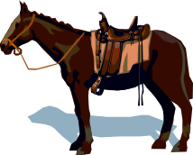

These comparisons are made to show that he is dangerous, uncontrollable, powerful and he has the low intelligence of an animal.
Animal | Quotation | Meaning
TERRIER
BEAR
HORSE

Slim
- Read the quotations and adjectives about Slim.
- Find other quotations and your own comments to expand upon these points.
- Use them to answer the following question.

With reference to the ways that Steinbeck presents Slim, show that he is a character who is respected by the other men on the ranch.

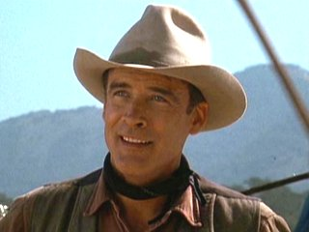

special ‘majesty’

‘prince of the ranch’ ‘authority’

when he meets George and Lennie, he looks at them ‘kindly’

good leader respected

understanding of George and Lennie’s relationship

skilful calm
Create a character profile for Candy.
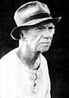
Write a paragraph, with supporting quotation, under each heading.

- Harmless yet mean

- His relationship with his dog

- Appearance

- Frail and Powerless

- Hopes for a better life

Other Major Themes

  - Outsiders / Minorities
  - Relationships
  - Death / inevitability

- Discuss the significance of each theme in the novel.
- Discuss which characters are associated with each theme and why (provide quotations to support your comments).

Essay Practice – Functional Writing for
GCSE English Language (unit two)

Learning Intention: To present information on a topic in such a way as to persuade the reader to adopt your point of view.

‘George needs Lennie as much as Lennie needs George.’ Discuss.

Exemplar essay (first page only)

‘Of Mice and Men’, by John Steinbeck, explores the relationship between two itinerant ranch workers, George and Lennie, in the Depression era of 1930’s America.

A major theme in the novel is friendship and Steinbeck explores the bond which exists between George and Lennie, in an environment where such relationships were unusual.

The two men rely upon each other for a variety of reasons. However, is one character more dependent than the other or does George need Lennie as much as Lennie needs George?

Firstly, I believe that from the very beginning of the novel, when Lennie gulps the stagnant water ‘like a horse’, it is apparent that Lennie’s needs are much greater. How else would he survive in their harsh environment were it not for George’s fatherly guidance?

REMEMBER:
The purpose of this essay is to persuade your reader to agree with your point of view. This can be done by using the following techniques
- Personal opinion supported by evidence (quotation / examples from the text).
- Discourse markers to introduce each new point / paragraph.
- Rhetorical questions.
- Awareness of your audience (we, you, etc.)
- Consideration of the other side of the argument and why you disagree.
- A conclusion which brings together your main points.
- Emotive language.
- Repetition / Rule of three in order to emphasise your point.

Self-Assessment
(George Needs Lennie as much as Lennie needs George. Discuss)

You will be marked on your ability to argue, persuade and advise in Functional writing (unit two GCSE English Language).

Read through your essay and tick if you have used the following techniques. If you have not, you will have to include them in your second draft in order to improve your work and to meet the success criteria. Do this before you hand it in for marking.

Analysing your essay
Technique | Did I meet this? | How will I improve this in my second draft?
Introduction which refers to the theme of friendship and dependency.
Introduction which refers to the essay question.
Linking words / discourse markers used at the beginning of every paragraph.
Well developed points, which always relate back to the question e.g. Surely this evidence shows that Lennie’s needs are greater?
Phrases used to show your own opinion e.g. I strongly feel that this evidence proves that …
Appropriate quotations from the novel used to support each of your points (at least one to each paragraph)
Rhetorical questions (do not use phrases like ‘Wouldn’t you agree?’)
Have you shown the other side of the argument and explained why you feel it is not valid?
Conclusion stating your overall opinion and a summary of your main arguments.

The Fight between Curley and Lennie.
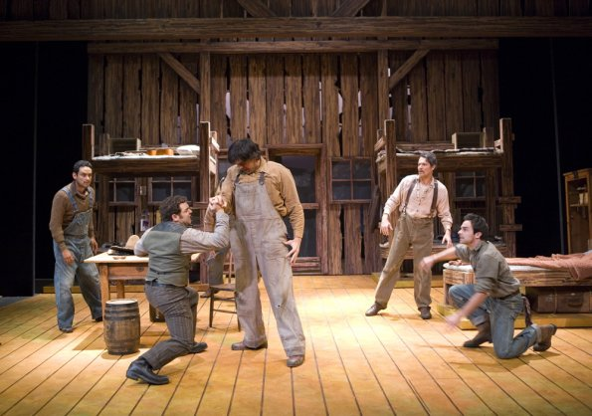

Answer the following question using the notes below:

Why does the fight occur
between Curley and Lennie?

There are many reasons why:
- Curley has a grudge against people who are bigger than himself.
- His attack on Lennie is carefully timed to shatter the dream-vision that George, Lennie and Candy were sharing. A reminder that DREAMS can only exist in the real world for a short time.
- Reminder that the world can be violent, cruel and unforgiving – particularly for people like Lennie.
- We see further evidence of Lennie’s child-like nature as he does nothing until he is ordered to fight back by George.
- Lennie and Curley are compared to animals.
- Lennie – ‘covered his face with his huge paws’, ‘bleated with terror’ ‘his fist lost in Lennie’s paw’
- Curley – ‘like a terrier’, ‘was flopping like a fish’
- This shows the struggle for survival – the struggle between the hunter and its prey. Lennie appears to look like a gentle bear, but he is actually extremely dangerous.
- We see Lennie’s overpowering strength and wonder just what he is capable of. He held on to Curley as if he was in a trance and could have killed him.It is a dangerous combination to have the mind of a child and such extreme physical strength.

Why does the fight occur between Curley and Lennie?
Starting your answer:
Conflict is a major theme in the novel Of Mice and Men. There is both emotional and physical conflict throughout. One of the most memorable instances of physical conflict is the fight between Curley and Lennie, which happens for many reasons.
Firstly,
Secondly,
Also,
Lastly,

Speaking and Listening (20% of Eng. Lang. GCSE) Activity

Group Discussion – Controlled Assessment – towards final GCSE English Language grade.

Homework: Think about the different characters, themes or symbolism in the novel.
Choose an object which you think symbolises one of these. Be prepared to explain why you chose this object and what it represents in the novel.

You can bring in
an object or a picture

For example,

You might want to discuss the conflict caused by racism in the novel, so you could bring in a picture of Crooks.

- You could discuss how black people were treated.
- How they were segregated.
- The conflict between Crooks and Lennie when he visits him.
- The conflict between Crooks and Curley’s wife.
- The conflict Crooks experiences between wanting to protect himself from hurt, yet also wanting some human company and dreams for the future.

You will be expected to discuss your object/picture and say
  - Why you chose this object.
  - What type of conflict it represents.
  - Why does this conflict exist in the novel?

You will be given a mark (it will be a third of your 20% Speaking and Listening grade).

This is a compulsory task.
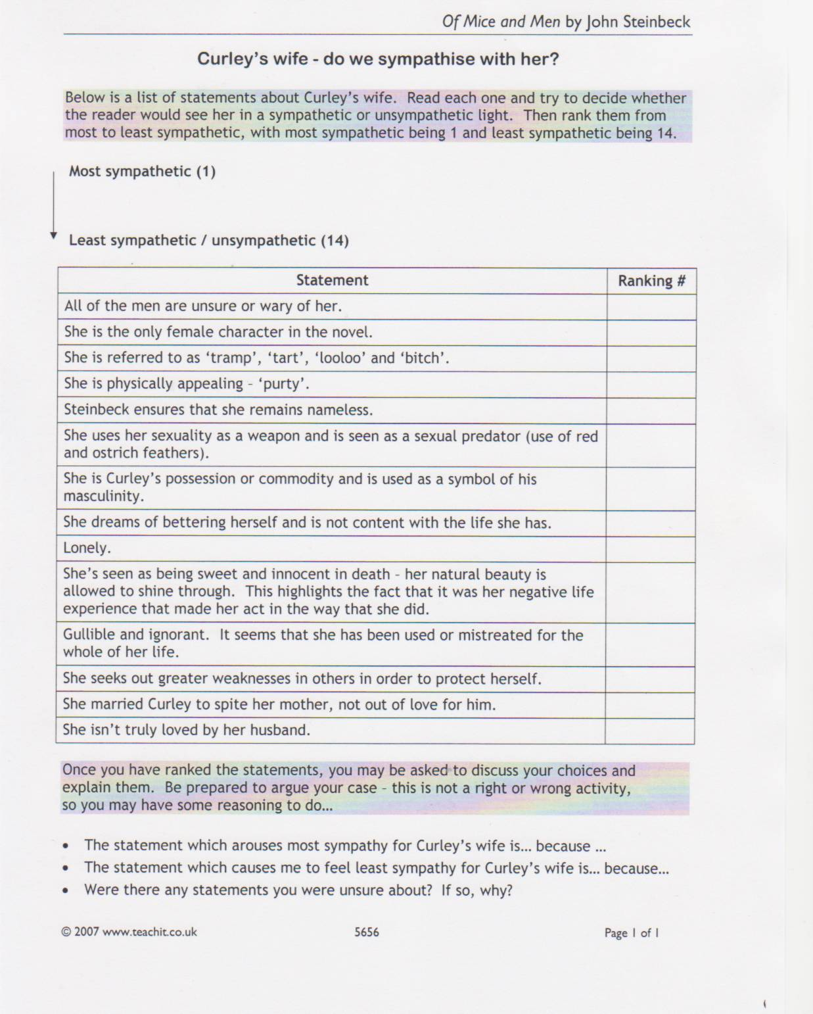

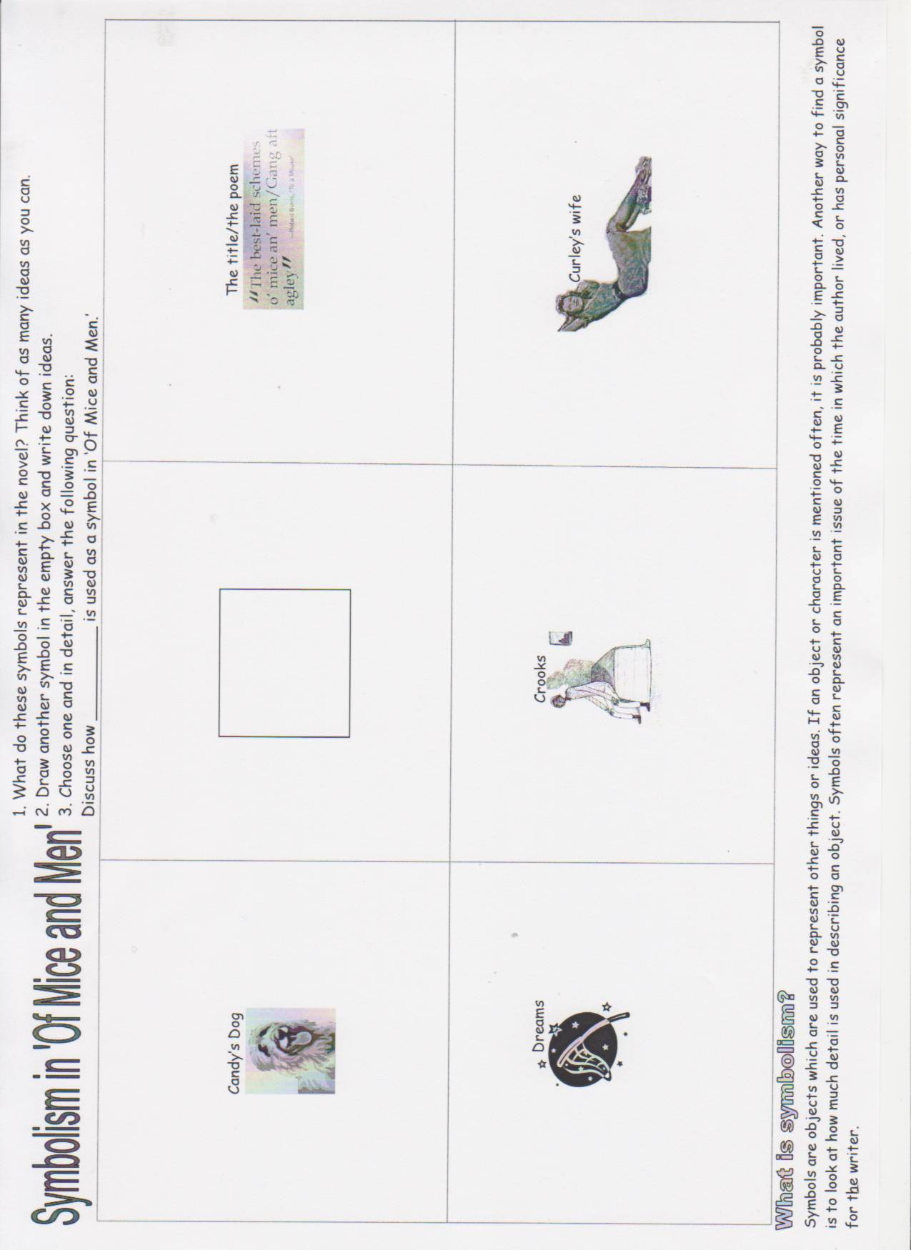

Chapter Six
The Ending

- Setting: why is the pool linked to death?

(include)
- Mouse
- Heron and snake
- Lennie

- Why does Lennie see a rabbit?

- Give two reasons why George doesn’t want to kill Lennie.
- Give two reasons why George has no choice but to kill Lennie.
- Find 3 pieces of evidence of George’s actions which show that he finds this a difficult thing to do.
1(adverb)
2(verb and adverb)
3(verb)

- Do you think George will live the dream without Lennie? Justify your answer.

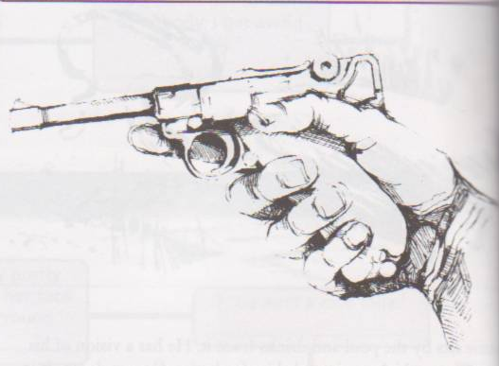

The Mercy Killing

George’s internal conflict concerning Lennie is finally resolved in the final section.

George knows that Curley will punish Lennie with a torturous death ‘Shoot for his guts’ (Curley). Therefore, George has to make an important decision between two conflicting actions.

- Does he try to escape with Lennie as they did before? Despite his complaints about Lennie, George loves him and Lennie provides George with the dream and escape from loneliness experienced by the other migrant workers – ‘Guys like us … are the loneliest guys in the world … With us it ain’t like that.’ (George).
- Does he kill Lennie himself, in order to protect him from Curley? He knows that this is the only solution to protecting Lennie from things like this happening in the future – ‘Ever’body gonna be nice to you. Ain’t gonna be no more trouble.’ (George)

In this section we see a paradox. George decides to kill Lennie, as he is being cruel to be kind.

Explain below why George kills Lennie and the conflict which it causes inside him.

George kills Lennie, his only friend and travelling companion, because ____________________________________________________________________________________________________________________________________________________________________________________________________________________________________________________________________________________________________________________________________________________________________________________________________________________________________________________________________________________________________________________________________________________________________________________________________________________________________________________________________________________________________________________________________________________________________________________________________________________________________________________________

What does the title ‘Of Mice and Men’ mean?
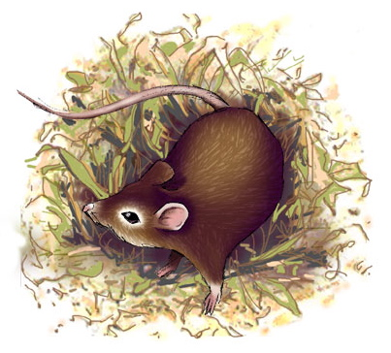

Robert Burns was a Scottish poet, but he did not make any money from his poetry. He earned most of his money from farming. It was while he was ploughing one of his fields that he disturbed a mouse’s nest. It was his thoughts on what he had done that led to his poem, ‘To A Mouse’ (1785).

Burns Original | Standard English Translation
But Mousie, thou art no thy lane,  In proving foresight may be vain:  The best laid schemes o' mice an' men  Gang aft agley,  An' lea'e us nought but grief an' pain,  For promis'd joy! | But Mouse, you are not alone,  In proving foresight may be vain:  The best laid schemes of mice and men  Go often askew,  And leave us nothing but grief and pain,  For promised joy!

- What do you think this verse means?
____________________________________________________________________________________________________________________________________________________________________________________________________________________________________________________________________________________________________________________________________________________________________________________

- How is the mouse’s fate similar to that of the characters in Of Mice and Men? Discuss with your response partner and complete the diagram on the following page.
How does the poem relate to the characters in Of Mice and Men?

________________________________________________________________________________________________________________________________________________________________________________________________________________________________________________________________________________________________________________________________________________________________________________________________________________________________________________________________________________________________________________
__________________________________________________________________________________________________________________________________________________________________________________________________________________________________________________________________________________________________________________________________________________________________________________________________________________________________________________
__________________________________________________________________________________________________________________________________________________________________________________________________________________________________________________________________________________________________________________________________________________________________________________________________________________________________________________
__________________________________________________________________________________________________________________________________________________________________________________________________________________________________________________________________________________________________________________________________________________________________________________________________________________________________________________

Controlled Assessment

Title: Discuss the relationship between George and Lennie.

You will have time in class and at home to prepare, but you will not be allowed to bring any notes into the controlled assessment.

I expect the following:

- The title of the novel – Underline the title of the novel throughout your essay – Of Mice and Men or place inverted commas around it ‘Of Mice and Men’.
- Language – Use clear formal language. Do not use shortened words e.g. use - do not, would not, cannot, etc.
- Author – Refer to John Steinbeck as Steinbeck throughout your essay, not John.
- Quotations – They must support your points. They should be short and relevant.

- Inverted commas should be placed at the beginning and the end of the quotation.
- Write out the quotation exactly as it appears in the book.
- Do not use a quotation that repeats what you have just written.
- You will need to memorise your quotations for your controlled assessment – know what was said and who said it.
TASK

Your homework is to write your introductory paragraph

Refer to
- The title of the essay
- Make the point that George and Lennie’s relationship is very important.
- Refer to the context of the novel.
- Briefly describe what their relationship provides for each of them.
- Do not begin – I am going to write about or We are reading …

  - A more suitable opening is included below.
  - Read this opening and highlight or underline where you can find the points 1-5 (above).

Can you find a quote to put on a line before your introductory paragraph, which you feel sums up George’s and Lennie’s relationship?

______________________________________________________________________________________________________________________

George Milton and Lennie Small are the central characters in Of Mice and Men by John Steinbeck, with a unique relationship which sits at the very core of the novel. These two migrant farm workers have an unusual and very special relationship, which meets their different needs, during a time when life was unpredictable and often harsh due to the Great Depression. Lennie relies on George for guidance due to his childlike mentality, whereas George’s role as Lennie’s father figure and protector provides him with the stability which so many of the migrant workers lacked and yearned for.

Planning
Why is their relationship unusual? (think of the other migrant workers during the Great Depression.)
1
2
3

Are there any other characters who have a slightly similar relationship?

Who cannot understand their relationship? Why do you think this is? (provide a quote)

George
What does he get from their relationship or what are his reasons for being with Lennie? (description and relevant quote)
1
2
3
4
5

Lennie
What does he get from their relationship? (description and relevant quote)
1
2
3
4
5
How does George display just how deeply he cares for Lennie? (description and quote)

How would you sum up their relationship?

Controlled Assessment Task for Unit 3: Speaking and Listening (this unit is 20% of your GCSE in English Language).

Candidates must be assessed in the context of a role play.

Picture the scene…

George has shot Lennie and has been taken to the court-house in the nearest small town, where the judge will hold an inquiry into Lennie’s death. He will do this by asking each of the witnesses about what happened. One member of your group will be the judge; the other parts are for Crooks, Curley, Candy, Carlson, Slim, the Boss and George himself. The judge can ask as many questions as he or she likes, and can call on any of the characters at any time to back up or deny what someone else has said.

The judge starts by asking each person
- Who are you and what do you do on the ranch?
- How did you discover the dead man had been shot?
- What do you think about the shooting?

The judge will then continue to ask questions which are specific to each character.

You will be given a card with a character’s name on it. You must research your character and be prepared to answer questions about Lennie’s death and the events leading up to it.

This is a compulsory controlled assessment.
ENGLISH LITERATURE EXAM PRACTICE

What type of questions will there be and how will they be marked?

Foundation Style Questions
Answer either (a) or (b)
(a) With reference to extract 6 and elsewhere in the novel show that Candy is a pitiable
character.
In your answer you should consider the presentation of:
• what Candy says and does in the extract;
• Candy’s relationship with the others who live and work on the ranch;
• Candy’s attitude to George and Lennie’s dream.
(Use extract 6, printed in the Resource Booklet, to answer this question.)
The passage begins “Damn right he is,” said Carlson and
ends with “Candy lay rigidly on his bed staring at the ceiling.”

(b) Show that the lives of the ranch workers are lonely.
In you answer you should consider the presentation of:
• George;
• Candy;
• Crooks.

How will they be marked?
There are two assessment objectives: A01 and A02.
Assessment Objective 1:
- Respond to texts critically and imaginatively; select and evaluate relevant textual detail to
- illustrate and support interpretations.

This will be conveyed by the candidate’s ability to:
• demonstrate knowledge and understanding of the text;
• understand and communicate explicit and implicit meanings;
• substantiate point of view by relevant reference, inference and deduction, using appropriate and
effective quotation as required;
• express convincing and supported personal responses, opinions and preferences;
• provide insights into characters, relationships, attitudes and values.

Assessment Objective 2:
- Explore how language, structure and form contribute to writers’ presentation of ideas,
- themes and settings.

This will be conveyed by the candidate’s ability to:
• comment meaningfully on the texts studied referring to the appropriateness of the form and
structure adopted by the writer;
• describe and appreciate the effectiveness of general and specific uses of language and stylistic
devices;
• appreciate changing mood, atmosphere and tone and comment upon how they are achieved.
Assessment Objective 2 requires candidates to “explore how language, structure and form
contribute to the meanings of texts.”

Key terms in the question:
“In your answer you should consider the presentation of…”
Consideration of structure (e.g. “up to this point”, “as the novel progresses”)
And/Or
Key terms in the bullets:
- the named writer’s use of language (e.g. “describes”) characters’ thoughts and feelings;
- characters’ reactions;
- characters’ behaviour;
- characters’ words/dialogue and interaction.
When assessing candidates’ responses to prose, some of the following uses of language and stylistic
devices may be noted. (This list is neither prescriptive nor exhaustive, but is intended as a helpful
guide to examiners.)
- structure of the text: chapters, climax, sequential/chronological ordering, flashback, conclusion;
- descriptive techniques (e.g. vocabulary choices, use of imagery and the senses);
- creation of setting (e.g. time, place, mood);
- creation of character (e.g. through narrator’s descriptions, use of dialogue, actions);
- narration (e.g. omniscient narrator, 1st person narration, use of persona, autobiography);
- cohesive elements (e.g. repetition of words or ideas, climax, suspense, sequential ordering):
- use of punctuation and other typographical effects (e.g. italics, capitalisation, suspension
points).

FOUNDATION QUESTION MARK SCHEME
(a) With reference to extract 6 and elsewhere in the novel, show that Candy is a pitiable character.
In your answer you should consider the presentation of:
• what Candy says and does in the extract;
• Candy’s relationship with the others who live and work on the ranch;
• Candy’s attitude to George and Lennie’s dream.
Examiners should note that candidates must address the stem of the question.
Reward candidates who can present a personal response and informed argument (AO1), backed up with
understanding of the writer’s methods and intentions (AO2).

- Band 0 None 0
- Band 1 Very Little 1–10
- Band 2 Emerging 11–20
- Band 3 Some 21–30
- Band 4 Competent 31–40

The following textual details may be used as supporting material.
The words in bold may form part of an argument.
In the extract:
• Carlson demands that Candy removes the dog from the bunkhouse;
• Candy feels he has to apologise for the smell;
• the old dog has been with Candy for a long time; it is his only companion;
• Candy “squirmed uncomfortably” when Carlson suggests shooting the dog;
• Candy speaks “softly”, the dog is a sensitive topic;
• Candy looked “helplessly” at Slim;
• Candy feels inferior to Slim “for Slim’s opinion were law”;
• Candy is clearly in a hopeless position as he looked for “help from face to face” - but receives no
support from the others;
• Candy tries to divert Carlson’s attention with the letter;
• Candy watches Carlson “uneasily”;
• Candy tries to delay Carlson from shooting the dog but to no avail, so he capitulates to Carlson.
Candy’s relationship with the others who live and work on the ranch:
• Candy is an inherently passive man;
• he serves as a guide to George and Lennie when they arrive on the ranch;
• he “shuffles past” Curley;
• he has lots of duties around the ranch, e.g. setting out washbasins;
• he is entirely dependent on others;
• he makes derogatory comments about Curley’s wife, “lousy tart”.
Candy’s attitude to George and Lennie’s dream:
• he does manifest an interest in others and does share a dream with George and Lennie;
• Candy suggests pooling money primarily because he knows that it will mean that George will look after him;
• he worries that the death of Curley’s wife will destroy his chances of buying land with George and Lennie.
(b) Show that the lives of the ranch workers are lonely.
In your answer you should consider the presentation of:
• George;
• Candy;
• Crooks.
Examiners should note that candidates must address the stem of the question.
Reward candidates who can offer a personal response and informed argument (AO1), backed up with
understanding of the writer's methods and intentions (AO2).

- Band 0 None 0
- Band 1 Very Little 1–10
- Band 2 Emerging 11–20
- Band 3 Some 21–30
- Band 4 Competent 31–40

The following textual details may be used as supporting evidence.
The words in bold may form the basis of an argument.
George:
• speaks repetitively/hypnotically/hauntingly of loneliness: “guys like us … are the loneliest guys
in the world. They got no family. They don’t belong no place …”;
• he feels he has to lie and tell the boss (who has asked intrusive and insulting questions) that Lennie
is his cousin, rather than admit he needs the company;
• he describes the life of migrant workers: how the migrant workers are always moving from ranch
to ranch, make some money, “blow their stake” and move on to another ranch;
• he and Lennie arrive at a very lonely spot, with no habitation for miles around, with the name
Soledad indicating loneliness;
• he plays solitaire, a symbol of loneliness, when Lennie is not around;
• he needs Slim’s understanding at the end of the novel, but even that is viewed with suspicion
(“now what the hell ya suppose is eatin’ them two guys?”).
Candy:
• he observes that “... a guy on a ranch don’t never listen nor he don’t ast no questions ...”;
• he is a useless cripple who cannot do the same work as the other ranch hands;
• he is too old to go out with the other ranch hands;
• his only companion is his dog;
• he allows it to be shot without putting up a fight for it, and with no one to side with him against
Carlson;
• he quickly latches on to the “dream”, perhaps as a way out of loneliness and as a means of assured
companionship and usefulness.
Crooks:
• he is coloured which automatically segregates him as a victim of racial prejudice;
• he is not permitted to sleep in the bunk house with the others;
• he has a happy childhood, in contrast with his present lonely life;
• he prefers to be on his own;
• he is left behind when the other workers go to town;
• he is abused by the Boss, the butt of jokes and games;
• he is forced to live in an isolated shack.

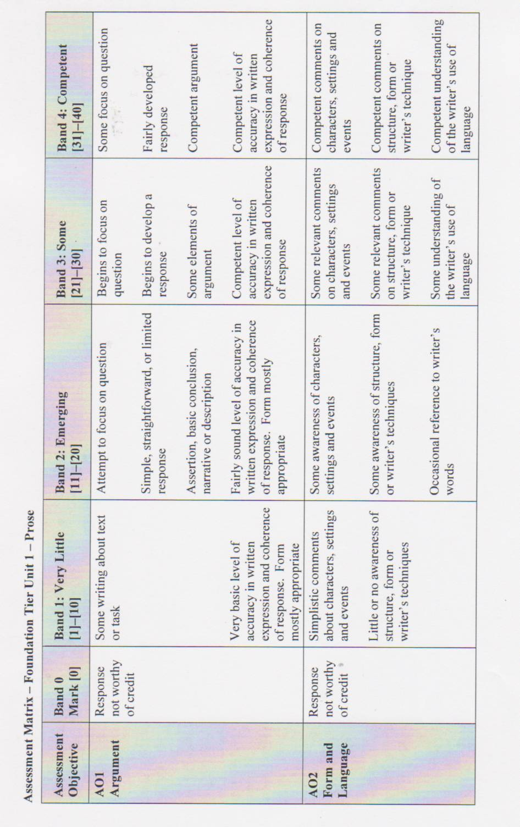

Higher Question

Answer either (a) or (b)

(a) With reference to the ways Steinbeck presents Candy in extract 6 and elsewhere in the
novel, show how far you would agree that Candy is a pitiable character.
(Use extract 6, printed in the Resource Booklet, to answer this question.)

(b) With reference to the ways Steinbeck presents the ranch workers, show how far you would
agree that their lives are lonely.
You should refer to at least two characters from the novel.

Look at the foundation question again. What is different about the questions in the two tiers?

Higher Mark Scheme

(a) With reference to the ways Steinbeck presents Candy in extract 6 and elsewhere in the novel, show how far you agree that Candy is a pitiable character.
Reward candidates who can present a personal response and informed argument (AO1), backed up with understanding of the writer’s methods and intentions (AO2).

Band 0 None 0
Band 1 Very Little 1–10
Band 2 Emerging 11–18
Band 3 Competent 19–26
Band 4 Good 27–34
Band 5 Excellent 35–40

The following textual details may be used as supporting material.
The words in bold may form part of an argument.
In the extract:
• Carlson demands that Candy removes the dog from the bunkhouse;
• Candy feels he has to apologise for the smell;
• the old dog has been with Candy for a long time; it is his only companion;
• Candy “squirmed uncomfortably” when Carlson suggests shooting the dog;
• Candy speaks “softly”, the dog is a sensitive topic;
• Candy looked “helplessly” at Slim;
• Candy feels inferior to Slim “for Slim’s opinion was law”;
• Candy is clearly in a hopeless position as he looked for “help from face to face”- but receives no
support from the others;
• Candy tries to divert Carlson’s attention with the letter;
• Candy watches Carlson “uneasily”;
• Candy tries to delay Carlson from shooting the dog but to no avail, so he capitulates to Carlson.
Elsewhere in the novel:
• Candy is an old, crippled man who has lost his hand;
• he cares for his dog even when it is a burden to him;
• Candy is an inherently passive man;
• he displays his emotions through lack of action rather than through effecting change;
• he is entirely dependent on others;
• however he does manifest an interest in others and does share a dream with George and Lennie;
• Candy suggests pooling money primarily because he knows that it will mean that George will look after him;
• he makes derogatory comments about Curley’s wife, “lousy tart”;
• he worries that the death of Curley’s wife will destroy his chances of buying land with George and Lennie.
Expect a range of arguments on Candy, from those who see him portrayed as a decaying man meant to inspire the pity of those around him to those who feel that his negative attitude to Curley’s wife loses him some sympathy. Some candidates may discuss the parallels between Candy and his dog, a virtually worthless animal.
Candy serves as a guide to the ranch society for George and Lennie. He also serves as a detached observer. However some may see him as nosy and meddlesome.

(b) With reference to the ways in which in Steinbeck presents the ranch workers, show how far you agree that their lives are lonely.
You should refer to at least two characters from the novel.
Reward candidates who can offer a personal response and informed argument (AO1), backed up with understanding of the writer's methods and intentions (AO2).

- Band 0 None 0
- Band 1 Very Little 1–10
- Band 2 Emerging 11–18
- Band 3 Competent 19–26
- Band 4 Good 27–34
- Band 5 Excellent 35–40

The following textual details may be used as supporting evidence.
The words in bold may form the basis of an argument.
George:
• speaks repetitively/hypnotically/hauntingly of loneliness: “guys like us … are the loneliest guys in the world. They got no family. They don’t belong no place …”;
• he feels he has to lie and tell the boss (who has asked intrusive and insulting questions) that Lennie is his cousin, rather than admit he needs the company;
• he describes the life of migrant workers: how the migrant workers are always moving from ranch to ranch, make some money, “blow their stake” and move on to another ranch;
• he and Lennie arrive at a very lonely spot, with no habitation for miles around, with the name Soledad indicating loneliness;
• he plays solitaire, a symbol of loneliness, when Lennie is not around;
• he needs Slim’s understanding at the end of the novel, but even that is viewed with suspicion (“now what the hell ya suppose is eatin’ them two guys?”).
Candy:
• he observes that “... a guy on a ranch don’t never listen nor he don’t ast no questions.”
• he is a useless cripple who cannot do the same work as the other ranch hands;
• he is too old to go out with the other ranch hands;
• his only companion is his dog;
• he allows it to be shot without putting up a fight for it, and with no one to side with him against Carlson;
• he quickly latches on to the “dream”, perhaps as a way out of loneliness and as a means of assured companionship and usefulness.
Crooks:
• he is coloured which automatically segregates him as a victim of racial prejudice;
• he is not permitted to sleep in the bunk house with the others;
• he has a happy childhood, in contrast with his present lonely life;
• he prefers to he on his own;
• he is left behind when the other workers go to town;
• he is abused by the Boss, the butt of jokes and games;
• he is forced to live in an isolated shack.
Arguments for and against loneliness may include some of the following:
• company: whereas Crooks prefers his own company, Candy wants only his old dog. George needs to have someone for company;
• homeless: they are all homeless;
• reasons: Candy’s loneliness is because he is old, Crooks’s loneliness is because of his colour, George’s loneliness (even with Lennie as companion) is that he is constantly running away, unable to make lasting friendships;
• relationship with women: they are all wary of Curley’s wife and want nothing to do with her; George goes to the whorehouse;
• the future for each man may be considered (e.g. George may find lasting friendship with Slim and stay on at the ranch, or he may just drift and live a monotonous and lonely life like the other migrant workers, Candy will continue on at the ranch, but it is doubtful if Slim’s pup will take the place of his old dog, Crooks is trapped in his solitary life, but whether he is unhappy when he has his books and memories may be considered);
• popularity: George is viewed with suspicion; Crooks is a different colour; Candy is too old.

